Floristical Characteristics in Cao Duong mountain of Cham Chu
Nature Reserve Area
Phạm Thị Oanh, Nguyễn Thị Tươi
Khoa Toán và Khoa học tự nhiên
Email: oanhpt83@dhhp.edu.vn
Ngày nhận bài: 30/9/2019
Ngày PB đánh giá: 03/12/2019
Ngày duyệt đăng: 10/2/2020
Abstract. In this article, the characteristics of flowering plants on Cao Duong mountain were identified and the vascular plant species grown here. Approximately 657 specimens were collected from this area in which Cao Duong flora comprises five branches with a total of 192 species belonging to 164 genera and 91 families. Twenty two species are non-flowering vascular plants (1 Psilotophyta, 5 Lycopodiophyta, 16 Polypodiophyta). Twelve species belong to Pinophyta, while the other 158 are Magnoliophyta. The biological spectrum of Cao Duong flora was set up as: SB = 84.89 Ph + 5.21 Ch + 2.60 Hm + 6.77 Cr + 0.52 Th.
Key Words: Vascular plants, Flora, Cao Duong, Cham Chu, Ham Yen, Tuyen Quang
Đặc điểm hệ thực vật núi Cao Đường, khu Bảo tồn thiên nhiên Chạm Chu
Tóm tắt: Trong bài viết này, đã xác định được các đặc điểm của thực vật có hoa núi Cao đường và ghi nhận những loài thực vật có mạch phát triển ở đây. Khoảng 657 mẫu vật đã được thu thập từ khu vực này, theo đó hệ thực vật núi Cao Đường gồm 5 ngành với tổng số 192 loài thuộc 164 chi và 91 họ. Trong đó, 22 loài là thực vật có mạch sinh sản bằng bào tử (1 loài ngành Lá thông, 5 loài ngành Thông đất, 16 loài ngành Dương xỉ). 12 loài thuộc về ngành hạt Trần, 158 loài là ngành hạt Kín. Công thức phổ dạng sống của hệ thực vật Cao Đường là SB = 84.89 Ph + 5.21 Ch + 2.60 Hm + 6.77 Cr + 0.52 Th.
Từ khóa : Thực vật bậc cao có mạch, hệ thực vật, Cao Đường, Chạm Chu, Hàm Yên, Tuyên Quang.

1. Introduction
Cham Chu Nature Reserve is situated in Ham Yen and Chiem Hoa districts of Tuyen Quang province in Vietnam, from 22º04’16’’ - 22º21’30’’N to 104º53’27’’ - 105º14’16’’E. Cao Duong is small area in the core zone of Cham Chu Nature Reserve. About 74 households live in Cao Duong. The majority of the people who are living in Cao Duong belong to the Tay, Dao, Nung, Muong, Cao Lan, Kinh, H’Mong ethnic groups. Their life still depends on forest resources, non timber forest products, as well as timber trees. There is not any studies of the plant of Cao Duong before. This study deals with the diversity of plant families, genera, species, life form, their conservation status, useful plants for the plant species recorded during five months in Cao Duong in 2018 as a base for the biodiversity reservation.
Soil: - Yellow feralit soil at average altitude contains a lot of humus
- Red yellow feralit soil at higher altitude, thin soil layers with humus
- Red yellow feralit soil at the side of the hill and the foot of a mountain
- Dark feralit soil at the foot of limestone
Climate: Cao Duong Region consisted two clear seasons: raining season begins April until September with the high humidity and a lot of rain; dry season from October until next year March with cold and dry wind.
Ecology: The most of ancient limestone with overgreen dense forest is running from Canh Tien range to Cao Duong peak. The other are the soil forest that is very little in area.
So we chose this research area for the following reasons:
2. There are no floristic studies from this area
1. Cham Chu mountain is recognized the nature reserve area and Cao Duong in the core zones of the Cham Chu.

2. Materials and methods
The materials of this study are 657 vascular plant specimens that were collected from Cao Duong mountain in 2018. Efforts were made to collect both flowering and fruiting specimens. The specimens were prepared according to established herbarium techniques. Subsequently, The Flora of Vietnam (Pham Hoang Ho, 1999-2000); Vietnam Forest Trees, 1971-1988; Averyanov, 1994; Nguyen Tien Ban, 1997; The list of plant in Vietnam, 2001-2005) and the other related floras (Lecomte, 1907-1951; Petelot, 1952-1954; Aubreville et al., 1960-1996; Anonymous, 1979-1997; Wu and Raven, 1994-2002), and monographs (Mabberley, 1997; Nguyen Nghia Thin, 1997) were utilized in the identification of the specimens.
Moreover, some of the specimens were compared with the type specimens which have been keeping at the Herbarium of National University of Hanoi (HNU) during study period. The specimens belonging to genera which were difficult to determine had been sent to specialists as Ph.D. Do Van Hai (Acanthaceae), Ph.D. Do Thi Xuyen (Melastomataceae), Ph.D Luong Van Dung (Theaceae)… to minimize the errors. All the specimens are kept at the Herbarium of National University of Hanoi (HNU) at Hanoi. The flora list and authors were corrected and given according to the order in Brummitt (1992); Brummitt and Powell (1992); The list of plant in Vietnam (2001-2005).

3. Results
The following are some floristic properties of Cao Duong mountain of Cham Chu Nature Reserve Area.
3.1. Diversity of taxa of Cao Duong mountain
Diversity of phyla
At the end of this study on the 657 vascular plant specimens collected from the area, 192 species and 164 genera belonging to 91 families were established. Twenty two species are non-flowering vascular plants (1 Psilotophyta, 5 Lycopodiophyta, 16 Polypodiophyta). Twelve species belong to Pinophyta, while the other 158 are Magnoliophyta. Magnoliopsida and Liliopsida comprise 135 and 23 species, respectively (Table 1-2).
Table 1. Diversity of plant division of flore at Cao Duong mountain
Division | Family |  | Genus |  | Species
 | No | % | No | % | No | %
Psilotophyta | 1 | 1.09 | 1 | 0.61 | 1 | 0.52
Lycopodiophyta | 2 | 2.20 | 2 | 1.22 | 5 | 2.60
Polypodiophyta | 7 | 7.69 | 13 | 20.31 | 16 | 8.33
Pinophyta | 5 | 5.49 | 9 | 5.49 | 12 | 6.25
Magnoliophyta | 76 | 83.51 | 139 | 84.75 | 158 | 82.29
Total | 91 | 100 | 164 | 100 | 192 | 100
The differences are shown not only in division but also in classes of Magnoliophyta. The ratio of species of dicots/monocots is 5.87:1 (Table 2).
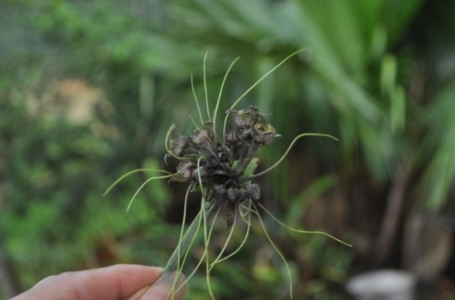  Tacca plantaginea (Hance) Drenth | 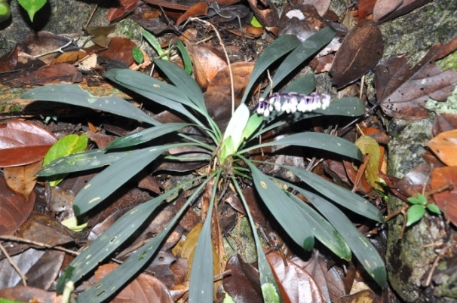  Ophiopogon tonkinensis Rodr.
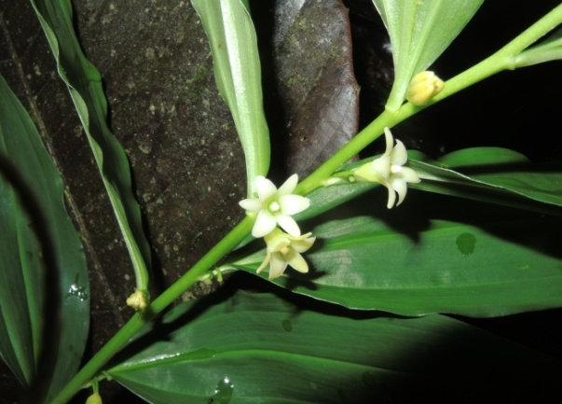  Disporopsis longifolia Craib. | 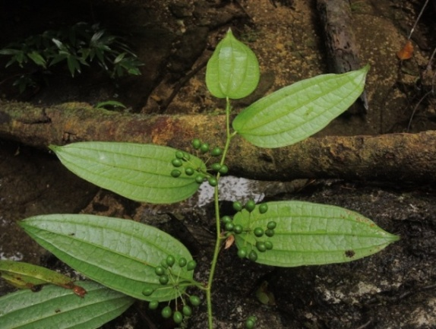  Smilax lanceifolia Roxb.
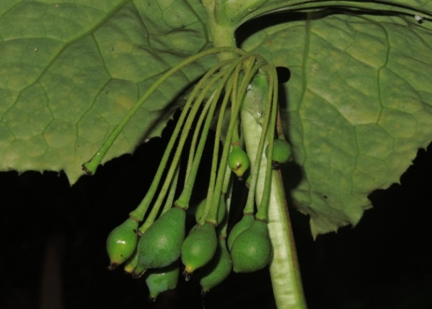  Podophyllum tonkinensis Gagnep. | 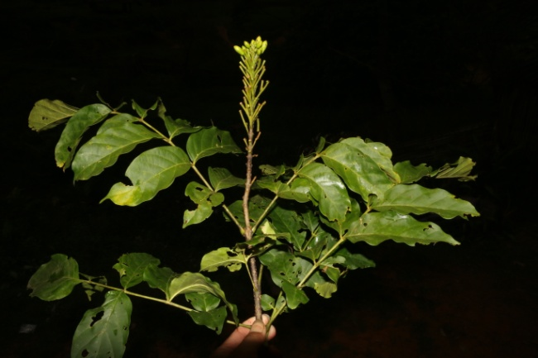  Fernandoa brilletii (Dop) Steen.
Fig.1. Some species belong to Liliopsida and Magnoliopsida
(Photo Pham Thi Oanh)
Table 2 shows that in Magnoliophyta, the Magnoliopsida has 135 species representing 85.44%; 116 genera representing 83.45% and 66 families representing 86.84% of the total species, genera and families, respectively in the flora.
Table 2. Distribution of taxa in the two classes of Magnoliophyta of flore in the area
Class | Family |  | Genus |  | Species
 | No | % | No | % | No | %
Magnoliopsida | 66 | 86.84 | 116 | 83.45 | 135 | 85.44
Liliopsida | 10 | 13.16 | 23 | 16.55 | 23 | 14.56
Total | 76 | 100 | 139 | 100 | 158 | 100
Diversity of families
Thirteen families comprise 81 of the 192 species established in the research area. In other words, 42.19% of the flora of Cham Chu consist of species that belong to 13 families. The rest of the 78 families include 111 species (57.81%). The 13 families that include the majority of the species and the numbers of species which belong to these families are listed in Table 3.
Table 3. Species totals of the biggest families found in the area
No | Families | Species number | No | Families | Species number
1 | Rubiaceae | 20 | 8 | Meliaceae | 4
2 | Orchidaceae | 10 | 9 | Araceae | 4
3 | Apocynaceae | 7 | 10 | Gesneriaceae | 4
4 | Lauraceae | 6 | 11 | Moraceae | 4
5 | Polypodiaceae | 6 | 12 | Zingiberaceae | 4
6 | Myrsinaceae | 4 | 13 | Urticaceae | 4
7 | Annonaceae | 4
Total |  |  |  |  | 81
Damp places, like banks of streams and meadows, occupy some parts of the study area. There is a rich vegetation of aquatic species belonging to families such as Begoniaceae, Ranunculaceae, Polygonaceae, Asteraceae, Campanulaceae and Scrophulariaceae in these habitats. Rubiaceae and Orchidaceae members are dominant on the mountain. There is a rich vegetation on the rocks above 950 m. There are also many annuals belonging to the families mentioned above in the area. There are relatively rich families and distribute widespread in Vietnam that found in study area as Rubiaceae, Annonaceae, Euphorbiaceae, Lauraceae, Orchidaceae, Araceae, Zingiberaceae.
Diversity of genera
About 18.22% of the species (35 species) belong to 10 genera (Table 4), whilst 154 genera are represented by one or few species in the area. Ophiorhiza L., Lysimachia L.,Psychotria L., Anoectochilus Blume, Mussaenda L., include more species. The species of these genera grow in both arid and damp places.
The dominant woody genera of the Magnoliophyta consist of Dipterocarpus Gaertn. f., Hopea Roxb. (Dipterocarpaceae); Sterculia L. (Sterculiaceae); Syzygium Gaertn. (Myrtaceae); Antidesma L. (Euphorbiaceae); Cinnadenia Kosterm, Cinnamomum Schaeff., Litsea Lamk. (Lauraceae); Ficus L. (Moraceae); Symplocos Jacq. (Symplocaeae); Garcinia L. (Clusiaceae).
Table 4. Species totals of the large genera in the study area
Genera/Family | Species number | Genera/Family | Species number
Ophiorhiza (Rubiaceae) | 5 | Aglaia (Meliaceae) | 3
Lysimachia (Primulaceae) | 4 | Smilax (Smilacaceae) | 3
Psychotria (Rubiaceae) | 4 | Ardisia (Myrsinaceae) | 3
Selaginella (Selaginellaceae) | 4 | Asplenium (Aspleniaceae) | 3
Anoectochilus (Orchidaceae) | 3 | Mussaenda (Rubiaceae) | 3
Total |  |  | 35
3.2. Diversity of life form of Cao Duong mountain
Life forms of plants in Cao Duong were determined based on the classification of Raunkiaer (1934). The existence of a variety of life forms reflects the typically tropical characteristics of the flora in Cao Duong (table 6).
Table 6. Life forms of plants in Cao Duong
Life forms | No | %
Phancrophytes (Ph) | 163 | 84.89
Chamaephytes (Ch) | 10 | 5.21
Hemicryptophytcs (Hm) | 5 | 2.60
Cryptophytes (Cr) | 13 | 6.77
Therophytcs (Th) | 1 | 0.52
Tổng | 192 | 100
The table 6 also showed that Phanerophytes (Ph) is the most dominant life forms with about 84.89% of total plant species in the area. The Spectrum of Biology (SB) of the plant in Cao Duong is summarized, as follows: SB = 84.89 Ph + 5.21 Ch + 2.60 Hm + 6.77 Cr + 0.52 Th.
The herbaceous plant composition varies with microclimatic conditions, and thus with habitat. Along streams or in damp valleys under the cool, shade forest canopy are several species of Acanthaceae, Begoniaceae, Gesneriaceae, Myrsinaceae, Piperaceae, and Urticaceae. Under the dense forest canopy in deep shade the few plants that can survive are those that do not depend on light for growth but rather obtain nutrients from decaying plant matter, such as the saprophytic Balanophorapierrei Van Tiegh. It is worth noting here that taxa of Aristolochiaceae, Begoniaceae, Gesneriaceae, and Urticaceae are very common in the flora of Cao Duong mountain.
The great number of species occur in Cao Duong mountain that have attractive flowers and leaves or interesting leaf shapes, particularly species of Aglaonema Schott, Arisaema Mart. (Araceae); Dendrobium Sw., Bulbophyllum Thouars (Orchidaceae) with attractive flowers and leaves. Many of these species could be valuable to horticulture as subtrobical ornamentals (The list of plant in Vietnam, 2001-2005).
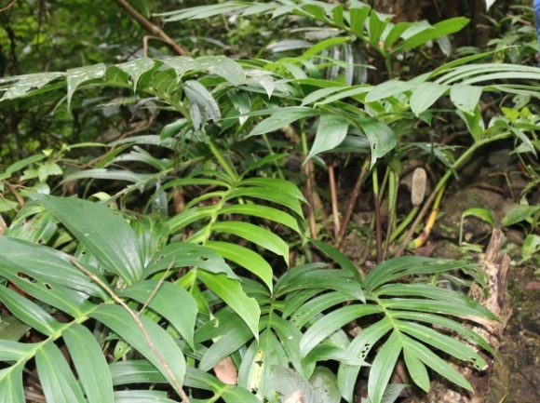  Epipremnum pinnatum (L.) Engl. & K. | 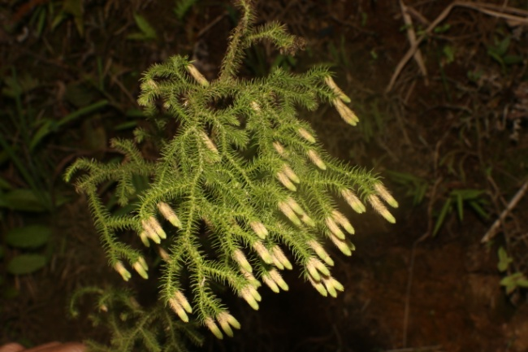  Lycopodiella cernuua (L.) Pic. Serm.
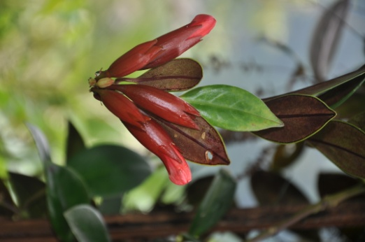  Aeschynanthus longicaulis Wall. ex R.Br. | 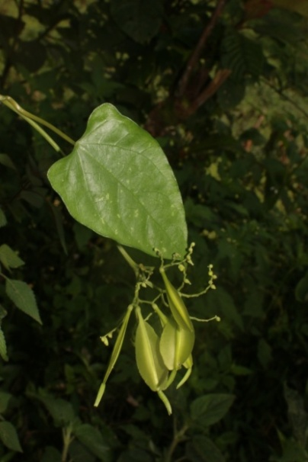  Peripterygium quinquelobum Hassk.
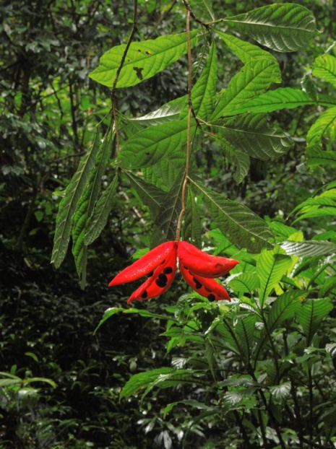  Sterculia lanceolata Cav. | 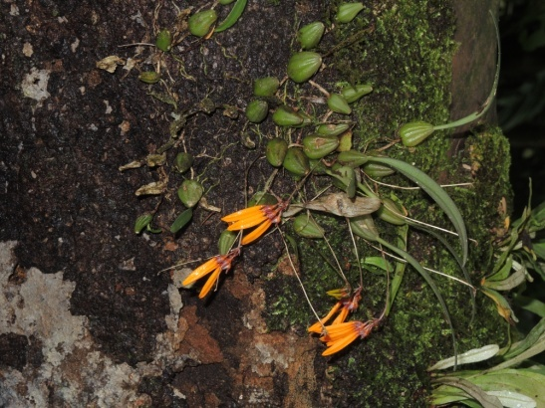  Cirrhopetalum retusiusculum  (Reichb. f.) Hemsl.
Fig.2. Some species with attractive flowers and leaves (Photo Pham Thi Oanh)
4. Conclusion
The composition of plants in Cao Duong was surveyed and identified with 192 species, 164 genera, 91 families of 5 divisions. The Magnoliophyta is the most diverse repersenting 82.29% of the total. The Spectrum of Biology (SB) of the plant in Cao Duong was as: SB = 84.89 Ph + 5.21 Ch + 2.60 Hm + 6.77 Cr + 0.52 Th.
Acknowledgements
The author wishes to thank the Manage Board of Cham Chu Nature Reserve Area, Departmant of Forest Tuyen Quang province for help during our sample collecting.

References
- Anonymous (1979-1997), Flora Yunnanica, Vol. 1-7. Yunnan Science Technology Press, Kunming, China.
- Aubreville A., M. L. Tardieu, J. E. Vidal et Ph. Mora (Reds.) (1960-1996), Flora du Cambodge, du Laos et du Vietnam, Fasc. 1-29, Paris, France.
- Averyanov L. V. (1994), Identification guide to Vietnam orchids (Orchidaceae Juss.) St. Petersburg, Russian, World and Family.
- Nguyễn Tiến Bân (1997), Cẩm nang tra cứu và nhận biết các họ thực vật hạt kín ở Việt Nam, NXB Nông nghiệp, Hà Nội, Việt Nam.
- Brummitt R. K (1992)., Vascular Plant Famies and Genera, Royal Botanic Gadens, Kew, UK.
- Brummitt R. K. and C. E. Powell (1992), Authors of Plant Names, Royal Botanic Gadens, Kew, UK.
- Phạm Hoàng Hộ (1999-2000), Cây cỏ Việt Nam, Tập 1-3. NXB Trẻ, Tp. Hồ Chí Minh.
- Mabberley D. J. (1987), The Plant Book, Cambridge University Press, UK.
- Lecomte H. (Edit.) (1907-1951), Flore generale de l Indo-chine, 7 tomes, Paris, France.
- Petelot A. (1952-1954), Les plants medicinales du Cambodge, du Laos et du Vietnam, Archives des Recherches agronomiques et pastorales du Saigon, Vietnam.
- Nguyễn Nghĩa Thìn (1997), Cẩm nang nghiên cứu đa dạng sinh học, NXB Nông nghiệp, Hà Nội, Việt Nam.
- Trung tâm Nghiên cứu Tài nguyên và Môi trường, ĐHQGHN; Tổ chức Phát triển Hà Lan; Viện Sinh thái và Tài nguyên Sinh vật (2001-2005), Danh lục các loài thực vật Việt Nam, Tập 1-3, NXB Nông nghiệp, Hà Nội, Việt Nam.
- Viện Điều tra Quy hoạch Rừng (1971 – 1988), Cây gỗ rừng Việt Nam, tập 1 - 7, NXB Nông nghiệp, Hà Nội, Việt Nam.
- Raunkiaer C. (1934), The Life Forms of Plants and Statistical Plant Geography, Claredon, Oxford University Press, Oxford.
- Wu P. and P. Raven (Eds.) (1994-2002),Flora of China,Vol. 3-79. Beijing & Louis, China.

